Name : Tamil Elakiya S Course : Software Engineering
Reg No : 192524443
Experiment – 2

Question : Sketch a Simple Prototype of a Bus Ticket Booking System using
Figma Tool.

Link : https://www.figma.com/design/nSm86mWtj8yQFjvAcdSMKU/Zing-Bus?node-id=202-4&p=f&t=sdFi8wB8nAw3LFvJ-0

Step 1: Open Figma
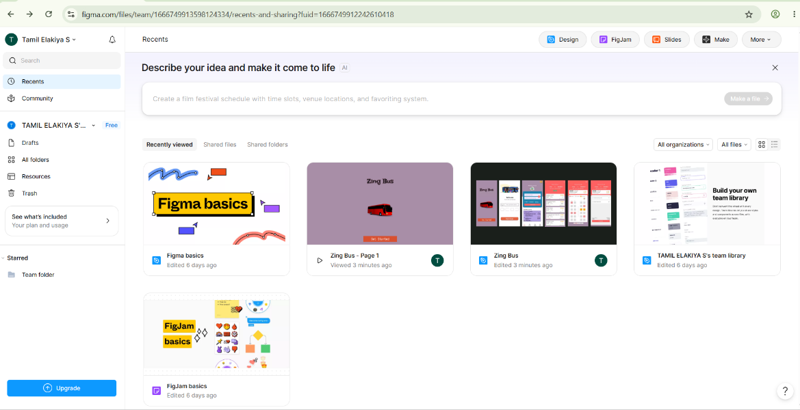

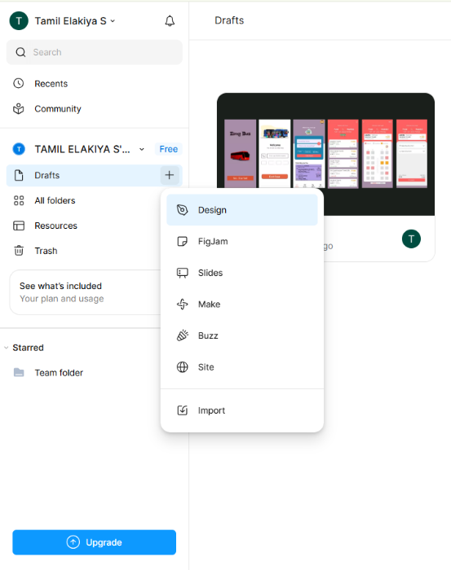
Step 2: Create the Project

Step 3: Design the Home/Login Page
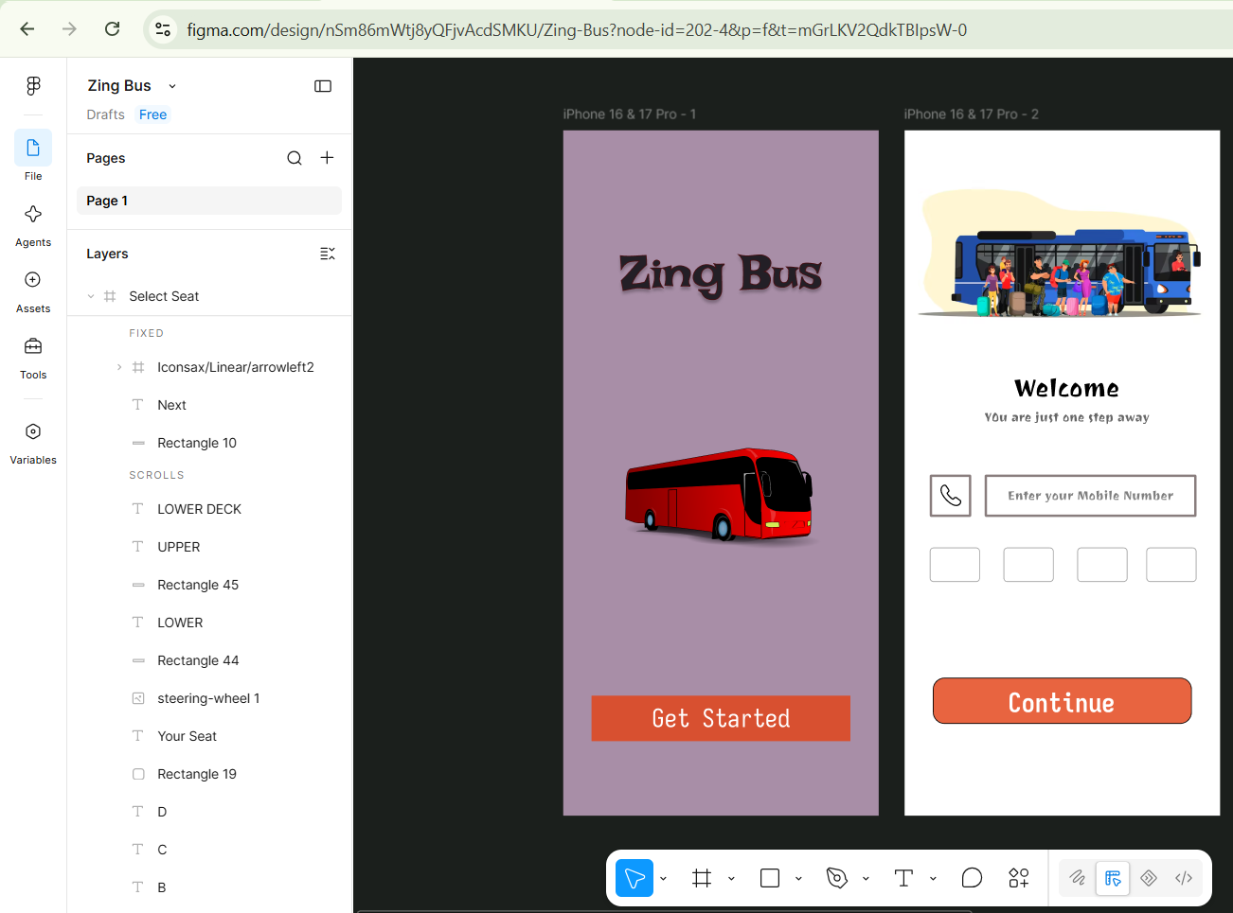

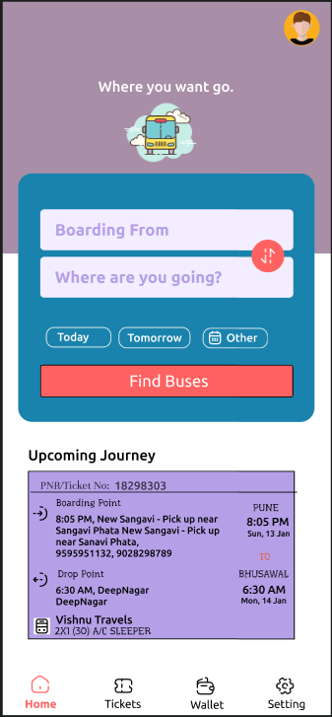
Step 4: Design the Bus Search Page

Step 5: Design the Bus Selection Page
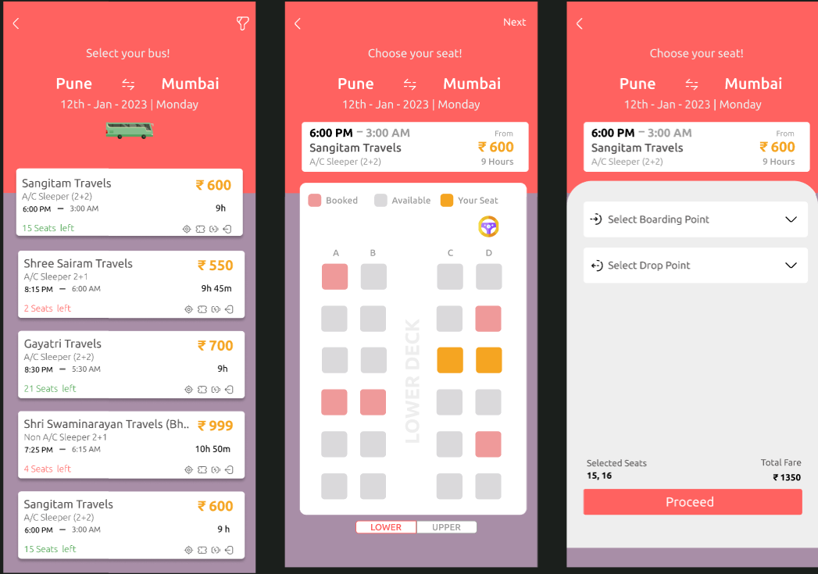

Step 6: Design the Seat Selection Page


Step 7: Design the Booking Confirmation Page


Step 8: Connect the Screens
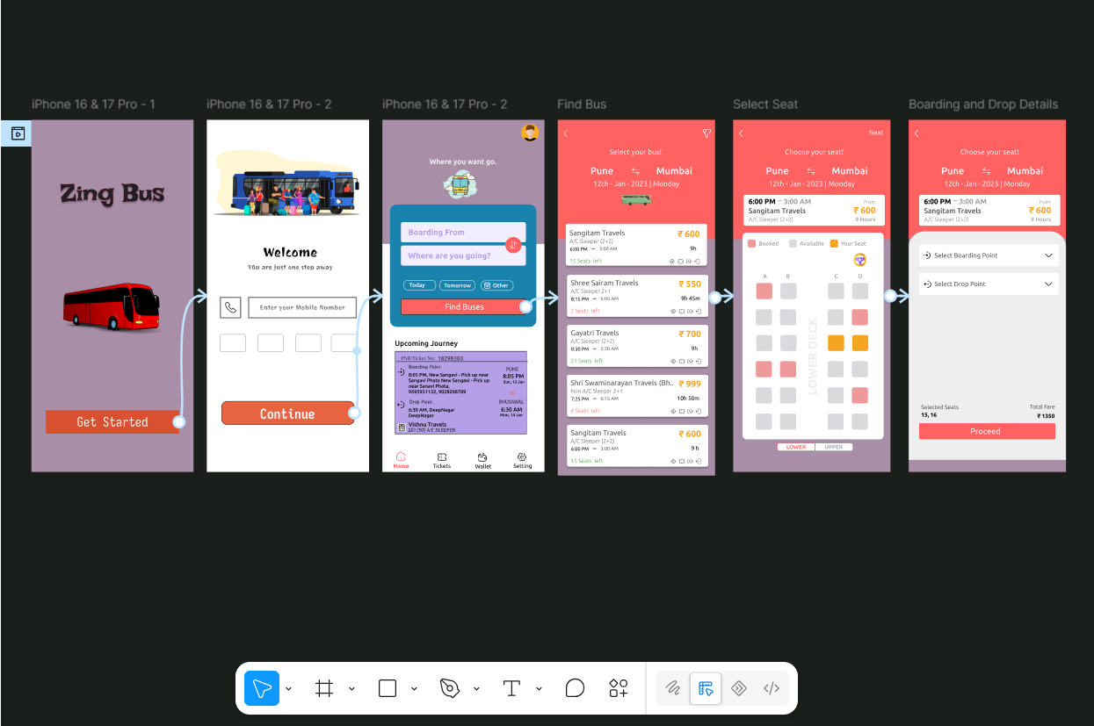

Step 9: Test the Prototype

